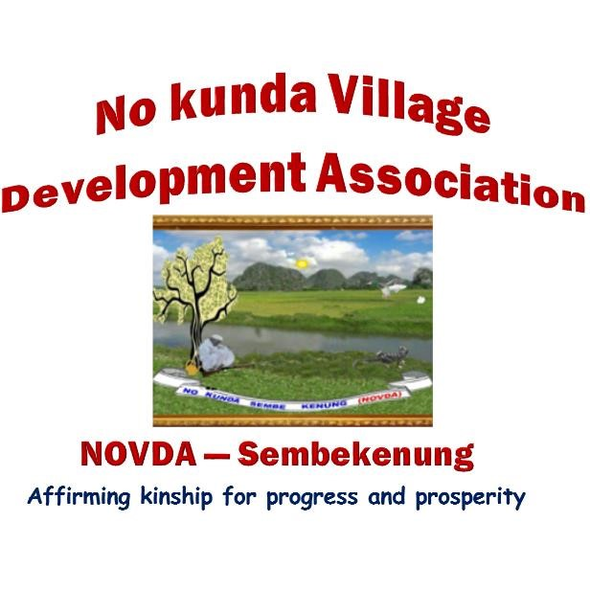

**NOVDA SEMBEKENUNG BY-LAWS**

**Section 1**

PLATFORM ADMINISTRATION (PLATFORM MANNERS, PRONOUNCEMENTS AND POSTINGS)

* 1. NOVDA Sembekenung shall for the purposes of effective communication open and administer platforms on Social media (WhatsApp, Telegram, etc.).
  2. All such platforms shall be named NOVDA Sembekenung, with alphabetical variations for purposes of clarity and differentiation (e.g. NOVDA Sembekenung A, B, C, etc.).
  3. All NOVDA Sembekenung platforms shall operate in strict accordance with the rules and regulations of the association as enshrined in the constitution or any by-laws designed for the purpose.
  4. Membership of the platforms shall constitute the people of No Kunda or such people as are deemed eligible by the Chairman/Central Committee due to their relationship with the association or by reason of marriage to a citizen of No Kunda in-so-far as the individual concerned is interested.
  5. Members' participation on the platforms shall be governed by the code of conduct of the NOVDA Sembekenung Platforms Administration.
  6. The platforms shall be used to sensitise members to raise funds; disseminate public interest information (for the benefit of members) as well as promote the culture, traditions and faith of members.

……………………………..

Dr Lang Fafa Dampha

Chairman NOVDA Sembekenung