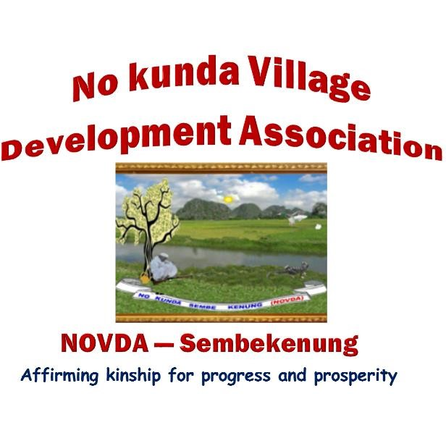

**NOVDA SEMBEKENUNG Platforms (Forums/Fora) Code of Conduct**

NOVDA Sembekenung recognises the importance of facilitating communication between and among its members and has *ipso facto* created a number of platforms on Telegram and WhatsApp for this purpose. In order to ensure the smooth and harmonious administration of the platforms, the following shall constitute the Code of conduct of the platforms:  
  
I. As a registered apolitical non-profit charity, NOVDA Sembekenung shall ensure that its platforms do not advance the agenda, views and interests of any political party.

II. NOVDA Sembekenung's platforms shall be used to advance and safeguard the image, interests and integrity of the association.

III. All members on NOVDA Sembekenung platforms shall desist from making politically biased statements; respect and defend the integrity of the association in their pronouncements, postings and interactions with other platform users.

IV. All members of NOVDA Sembekenung platforms shall refrain from making, forwarding or broadcasting statements, audios, videos or images castigating and/or demeaning any religious denomination.

V. Any member professing adherence to any denomination and interested in making statements or broadcasting teachings, views, opinions specific to their denomination on NOVDA Sembekenung platforms may do so on condition that such a broadcast does not openly denounce [an]other denomination(s).

VI. Membership of all NOVDA Sembekenung platforms is subject to the non-negotiable observance of zero tolerance on verbal abuse of all kinds and the posting of indecent images, nude or semi-nude photos or images, graphic videos or images of all kinds that bear no relevance to the cause of the association or the propagation of unsubstantiated information of all kind

VII. Members shall desist from bringing up or discussing personal and family issues, intimate or otherwise, on all NOVDA Sembekenung platforms.

VIII. Any member found in breach of these rules and regulations shall be advised to take heed in the first instance. A second breach shall attract a fine of £20/€20/$US20 for any member ordinarily resident in the UK, mainland Europe or the US respectively; D200 for members ordinarily resident in The Gambia and Senegal and the equivalent of $US10 in any other part of the diaspora.

IX. In the event of a third breach, the Chairman, in conjunction with the Central Committee, reserves the right to order the removal of the culprit(s) from the platform and any other NOVDA Sembekenung platform.

X. Where a member is fined, s/he shall be given 1 month from the date the notice of fine is dispatched in which to pay the fine.

XI. In the event of failure to settle the fine, the member shall be liable for a further offence the penalty for which shall be a 20% surcharge in addition to the initial fine, all to be paid within two weeks from the expiration of the deadline of the fine. This is unless there is/are extenuating circumstances.

XII. In the event of failure to pay the fine and any surcharge duly incurred, the Chairman shall determine whether the circumstances of the member in default satisfies the conditions for consideration of clemency.

XIII. Where the member in default has a reasonable excuse (see below) for not making the payment, s/he shall make a written application to the Chairman or Secretary-General before the expiry of the initial deadline explaining the reason why s/he is not able to pay the fine.

XIV. The conditions for consideration of clemency shall include a member suffering from ill health or otherwise financially constrained during the period of the fine. In the event the latter (financial constraint) is the plea, the option to defer or split the payment may be considered.

XV. Where a member is found/adjudged to be in deliberate breach recurrently, the Chairman reserves the right to order the removal of the member from all NOVDA Sembekenung platforms until such time as the member concerned makes a representation to the Chairman with a pledge to observe the letter and spirit of the code of conduct.

These codes of conduct shall be open to revision from time to time in order to make them more responsive to the purpose for which they have been formulated. All members and contributors on the platforms are hereby kindly urged to observe these codes of conduct in the interest of amicable exchange of views and ideas.

…………………………..

Dr. Lang Fafa Dampha

Chairman NOVDA Sembekenung